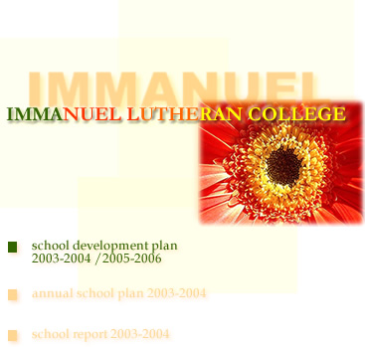

XXX School

School Vision & Mission

Where We Are Now
Prior to school development planning, it is advisable for schools to conduct a context analysis such as SWOT analysis to identify external opportunities and threats as well as internal strengths and weaknesses. Such a process would help determine strategic priority areas that a school needs to focus on for sustainable development and improvement of learning outcomes.

Our Strengths

Our Weaknesses

Our Opportunities

Our Threats

Major Concerns for 2003/04 – 2005/06 (in order of priority)

School Development Plan (2003/04 – 2005/06)*

Major Concerns  (in order of priority) | Intended Outcomes / Targets | Strategies | Time Scale  (Please insert ✓)
Major Concerns  (in order of priority) | Intended Outcomes / Targets | Strategies | 03/04 | 04/05 | 05/06
- Identify strategic priority areas with use of school evaluation data to sustain school improvement / development consistent with the school vision and mission  - The following points should be noted in the planning process:  - Enhance learning and teaching and improve student learning outcomes  - Align priorities with education and curriculum reforms (e.g. staff’s continuous professional development, 4 key tasks)  - Preferably NOT more than THREE major concerns within one planning cycle | - Define intended outcomes or targets that are observable, attainable and at the same time challenging | - Involve different stakeholders in the process of collaborative strategic planning  - Set priorities  - Adopt a realistic time scale

*Note: It is suggested that schools adopt a triennial planning and development cycle, thus providing adequate time for implementation of tasks and evaluation of work.

