North District Sports Ground Route Instructions
- Take the KCR and get off at Sheung Shui (上水火車站)
- Go up to the concourse. (If you get on the KCR at Tai Po or Fanling, you may walk to the back of the compartment and go up to the concourse directly.) | 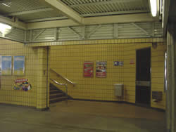
- Pass the exit. Turn right and go to the footbridge.
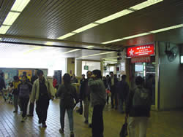 → 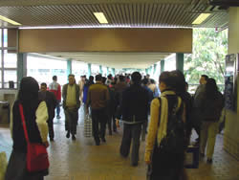
4. Take the first turning on your right in the footbridge and walk downstairs. | 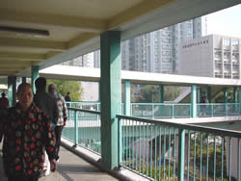

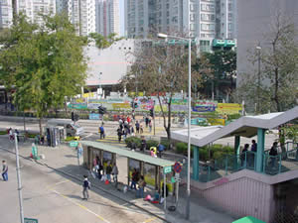 | 5. Cross the zebra crossing. The Town Hall(北區大會堂) is nearby.

6. Go straight on Lung Sum Road(龍琛路). Walk past Metropolis Plaza(新都廣場), Lung Fung Garden(龍琛花園) and a park.
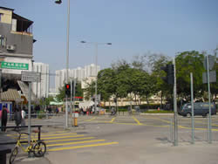 | 7. When you get to the crossroads, turn left and cross the zebra crossing.

8. Go straight on (about 1/2 minute), then cross the road by subway. | 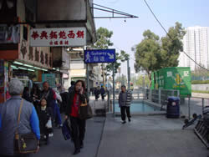
- Walk through the subway. You can see the sign of North District Sports Ground(北區運動場)
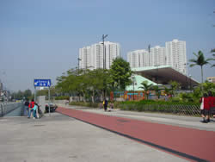 | 