WORK WORK WORK

A long time ago, there was an Emperor  who told his horseman 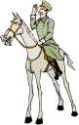 that if he could ride on his horse and cover as much land area as he likes, then the Emperor would give him the area of land he has covered.

Sure enough, the horseman quickly jumped onto his horse and rode as fast as possible to cover as much land area as he could. He kept on riding and riding, whipping the horse 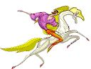 to go as fast as possible. When he was hungry or tired, he did not stop because he wanted to cover as much area as possible.

Came to a point when he had covered a substantial area and he was exhausted 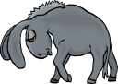 and was 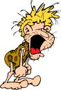 dying. Then he asked himself, "Why did I push myself so hard to cover so much land area? Now I am dying 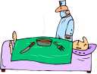 and I only need a very small area to bury 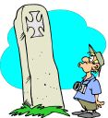 myself."

The above story is similar with the journey of our Life. We push very hard everyday to make more 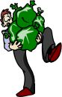 money, to gain power and 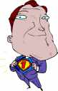 recognition. We neglect our health , time with our family 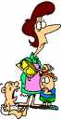 and to appreciate the surrounding beauty and the hobbies we love.

One day when we look back , we will realize that we don't really need that much, but then we cannot turn back time 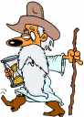 for what we have missed.

Life is not about making money, acquiring power or recognition . Life is definitely not about work! 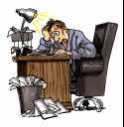 Work is only necessary to keep us living so as to enjoy the beauty  and pleasures of life. Life is a balance of Work and Play, Family and Personal time. You have to decide how you want to balance your Life. Define your priorities, realize what you are able to compromise but always let some of your decisions be based on your instincts. Happiness  is the meaning and the purpose of Life, the whole aim of human existence.
So, take it easy, do what you want to do and appreciate nature. Life is fragile, Life is short. Do not take Life for granted. Live a balanced 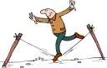 lifestyle and enjoy Life!

Watch your thoughts 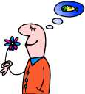 ; they become words.
Watch your words 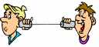 ; they become actions.
Watch your actions  ; they become habits.
Watch your habits; they become character  .
Watch your character; it becomes your destiny  

