To: Mathematics teachers
Uploading document into the Mathematics Web Page

INTRODUCTION

Every Class has a webpage in the mathematics webpage: http://www.ilc.edu.hk/SubjectWeb/MathsWeb/index.htm

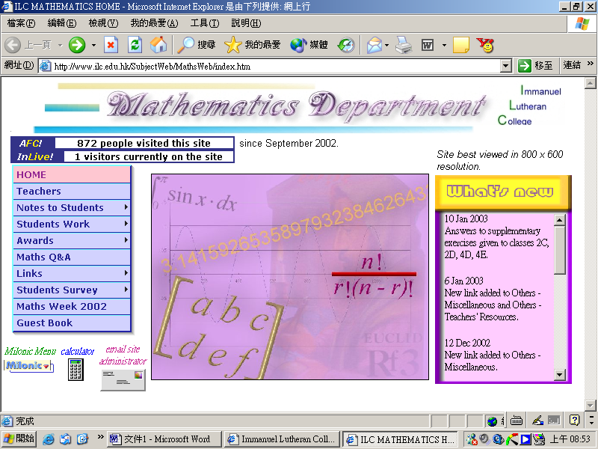

You may access the webpage of your class by clicking Notes to Students, then choose the Level and then the Class on the navigation panel on the left.
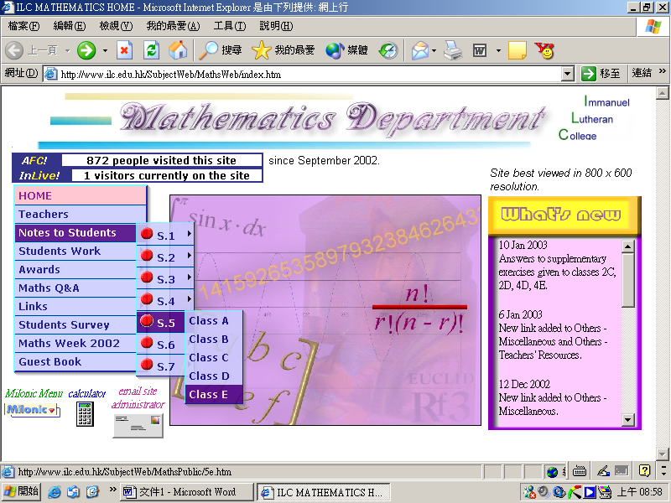


You may upload document, Word, Excel, Powerpoint, pdf, etc. to the webpage of your class so that students may get the soft copy of the document.

PROCEDURE

- Upload the document to the ftp server.
  - Open WS_FTP95 LE on the start bar.
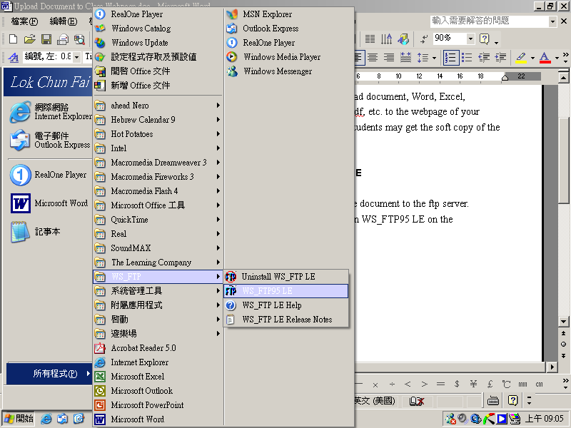
  - Username: ILCmaths
Password: Best2003
[both are case sensitive]
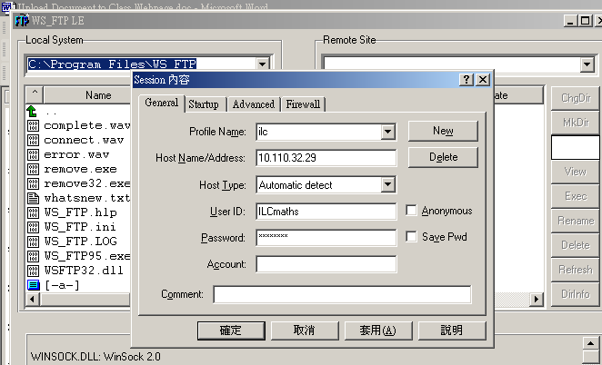

  - On the [Local System] (left side panel), go to folder that contains the document you want to upload, e.g. [-u-] or any other drive.
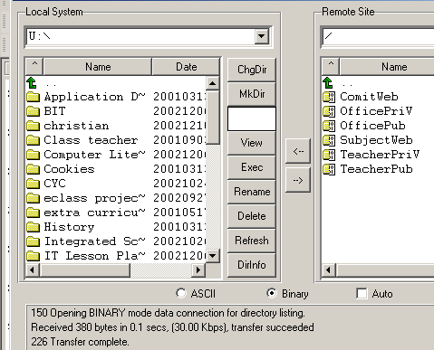
  - On the [remote site] (right side panel), choose [SubjectWeb] and then [MathsPublic].
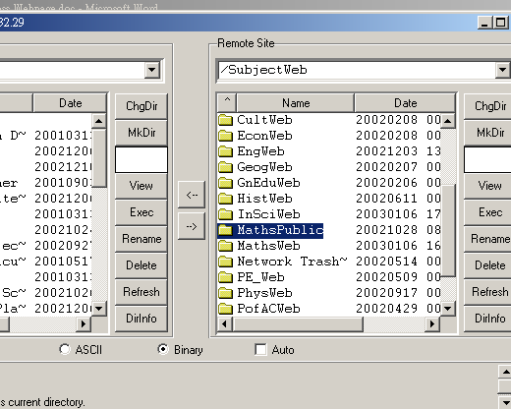
  - Open [Colleagues’ files], and then choose your folder and open it.
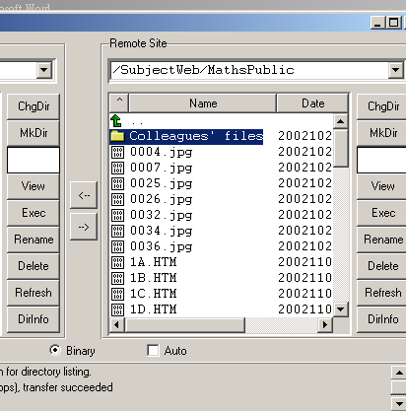
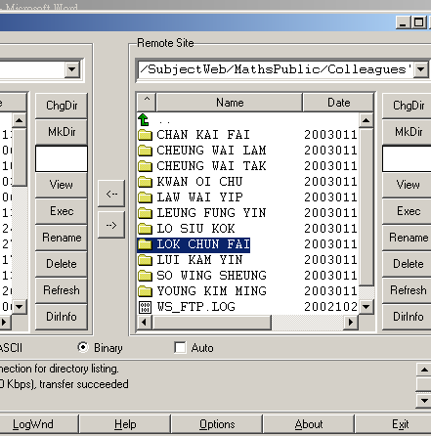
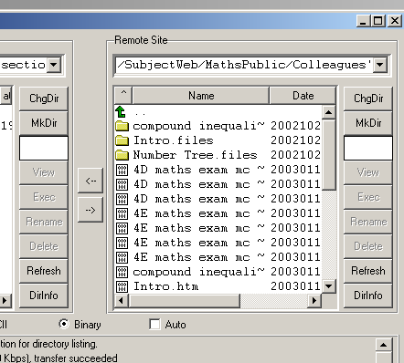
  - Highlight the document you want to upload on the left side panel ([local system])
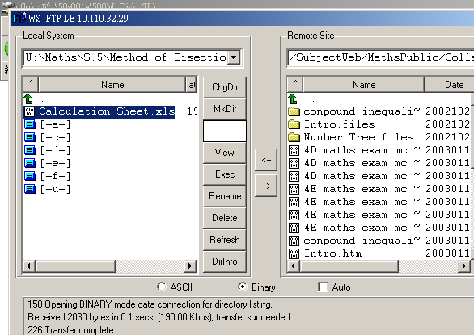
  - Press the upload button [->] to upload the file.
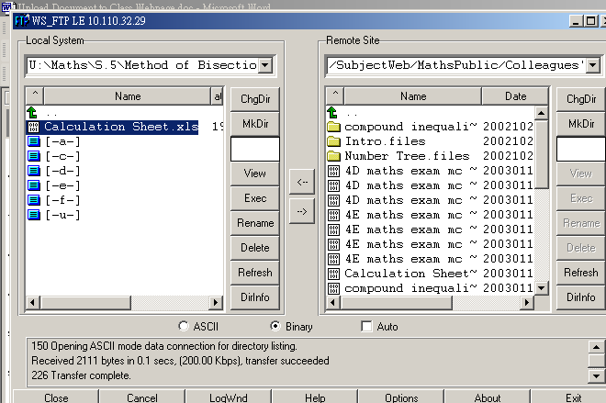
  - The upload is finished.

- Add a link on the class webpage to access to the uploaded document.
  - On the [remote site] panel, go up two levels back to the /SubjectWeb/MathsPublic folder
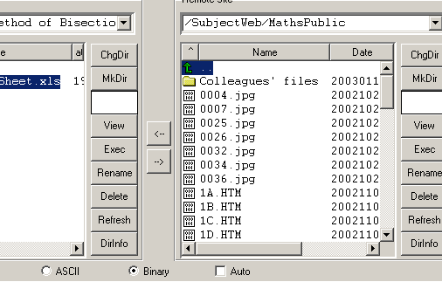
  - Find the class webpage you want to add a link and highlight it.
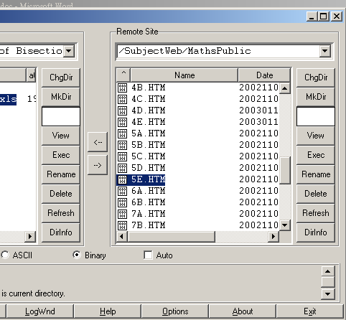
  - Change the [Local System] to the folder or drive where you want to edit the relevant class webpage.
  - Download the relevant webpage to your desired folder by clicking on the download button [<-].
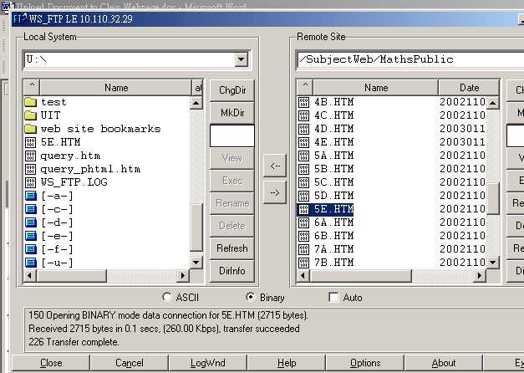
  - Use a webpage editing software like Dreamweaver to add a link on the relevant webpage. Open the webpage in Dreamweaver.
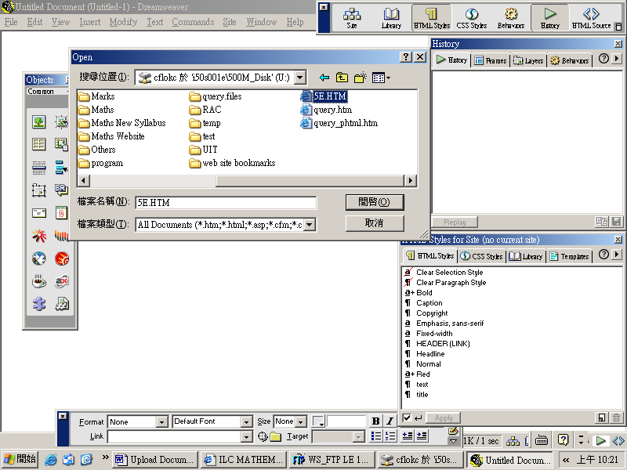
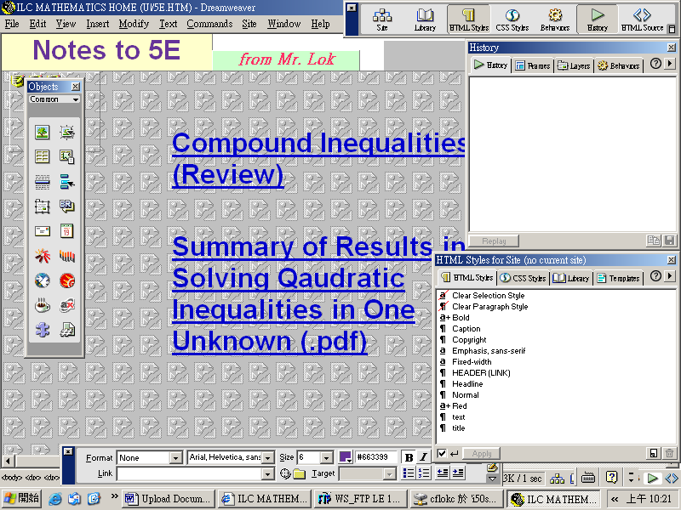
  - Type a name for the document you want the students to access. Change the colour and font as desired.
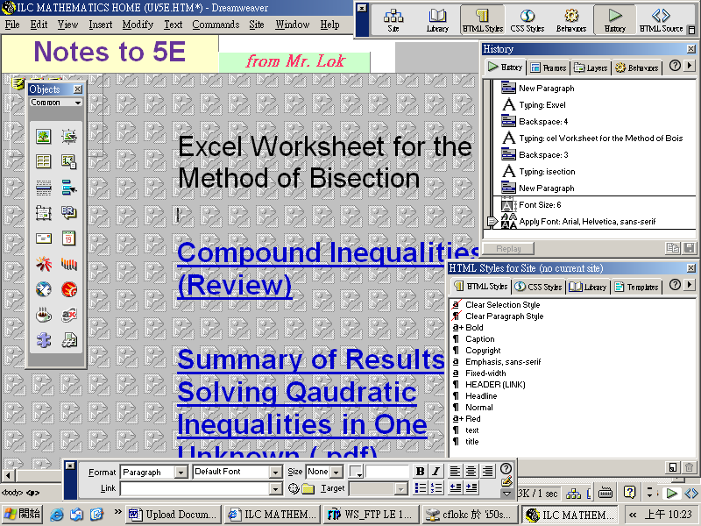
  - Highlight the name.
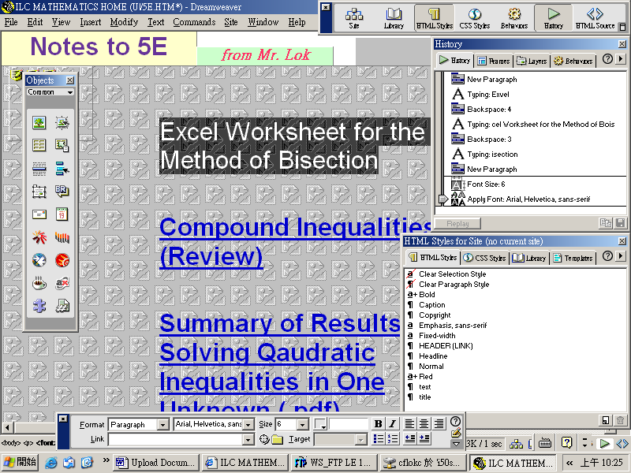
  - On the property dialogue box, on the field [Link], type:
Colleagues' files/LOK CHUN FAI/Calculation Sheet.xls
  - On the field [Target], choose [_blank].
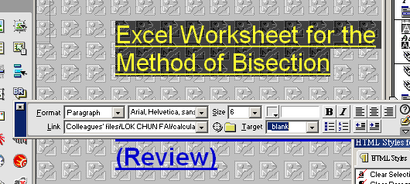
  - Save the renewed webpage and close Dreamweaver.
  - Switch back to WS_FTP LE. Press the [Refresh] button on the [Local System] panel.
  - On the local system panel, highlight the renewed webpage and press the upload button [->] to upload it to the ftp server again.
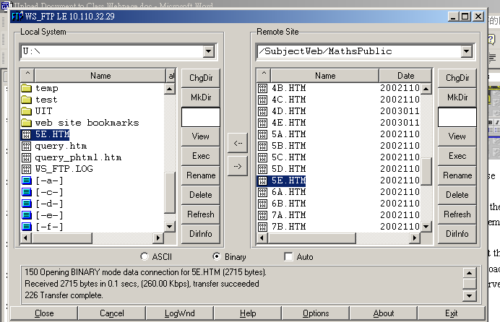
  - The job is finished. You may now check whether it works.

