Release date: Feb 2004

Book 1B (Section B Mechanics)

4 Time and Displacement

Warm-up 4.1 (p. 2)
1 Clock, stop-watch
2 (a)−(d) No definite answers.
A timing device should have a repetitive process separating equal intervals of time.

Check-point 1 (p. 5)
1 Day, month, year
2 True, true

Practice 4.1 (p. 6)
1 C
2 D

Warm-up 4.2 (p. 7)
(a) $3.8
(b) Disagree, agree

Check-point 2 (p. 12)
1 B
2 Scalar

Practice 4.2 (p. 13)
1 C
2 B
3 B

Revision exercise 4 (p. 15)
1 B
2 B
3 C
4 C

5 Motion

Warm-up 5.1 (p. 20)
1 No definite answers. The question asks Ss to think about the meaning of 'fastness' and the measure of how 'fast' an object moves.
2 (a) A circular area of radius 8 km (1.6 cm), centred at O.
(b) The direction in which the boy has been walking.

Check-point 1 (p. 25)
1 100, 9.53 m s^{–1} or 34.3 km h^{–1}
2 C
3 True
4 False

Check-point 2 (p. 27)
1 positive, negative
2 km h^{–1}, scalar
km h^{–1}, vector
km h^{–1}, vector
km h^{–2}, vector
3 They have the same acceleration.
4 For –ve acceleration, it will slow down (and later on, rest momentarily and move in –ve direction with increasing speed). For –ve deceleration, it will move in +ve direction with increasing speed.

Practice 5.1 (p. 28)
1 B
2 A

Warm-up 5.2 (p. 29)
1 B
2 B
3 4

Check-point 3 (p. 33)
1 D
2 B
3 25
4 False

Check-point 4 (p. 37)
1 C
2 C
3 False
4 True
Practice 5.2 (p. 38)
1 D
2 D
3 C
4 D

Warm-up 5.3 (p. 40)
C

Check-point 5 (p. 43)
1 A
2 False
3 C
4 C

Practice 5.3 (p. 44)
1 C
4 C

Warm-up 5.4 (p. 46)
1 the bottom left figure
2 displacement
3 negative, negative

Check-point 6 (p. 49)
1 D
2 A
3 False

Check-point 7 (p. 52)
1 C
2 C
3 braking, stopping
4 False

Practice 5.4 (p. 52)
1 B
2 C
3 B
4 B

Warm-up 5.5 (p. 54)
1 D
2
 | Car A | Car B
Velocity | + | –
Acceleration | – | –

Check-point 8 (p. 56)
1 C
2 False
3 False
4
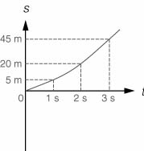
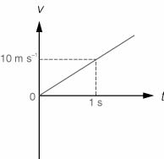
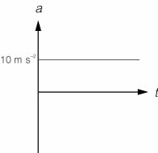

Check-point 9 (p. 60)
1 10 m s^{–1}
2 10 m s^{–1}
3 True
4 False
5 C

Practice 5.5 (p. 60)
1 C
2 C
3 D
4 C

Revision exercise 5 (p. 64)
1 C
2 C
3 C
4 A
5 B
6 D
7 (HKCEE 2000 Paper II Q4)
8 D
9 A
10 C
11 C
12 (HKCEE 2002 Paper II Q3)

6 Force and Motion

Warm-up 6.1 (p. 74)
1 No definite answers.
2 A

Check-point 1 (p. 79)
1 C
2 False
3 Zero net force
4 Net force, a constant speed, a straight line

Check-point 2 (p. 85)
1 False
2
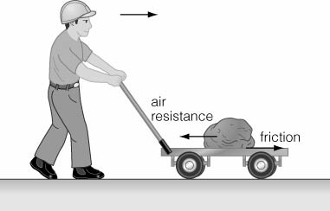
Air resistance, friction
3 (a) Air resistance, weight
(b) Accelerates, air resistance, decreases, net force, terminal speed

Practice 6.1 (p. 6)
1 C
2 C
3 C
4 B

Warm-up 6.2 (p. 87)
1 Tennis ball
2 C

Check-point 3 (p. 91)
1 A
2 B
3 Net

Check-point 4 (p. 94)
1 A
2
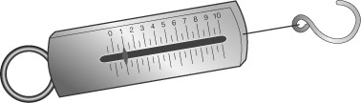
3
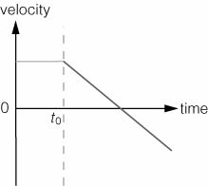
4 (a) 0 m s⁻¹, 15 m s⁻¹, 5 s, 90 kg, 3 m s⁻², 3 m s⁻²
(b) 3, 270 N, 270 N

Practice 6.2 (p. 94)
1 C
2 C
3 C

Warm-up 6.3 (p. 96)
1 B
2 C
3 B

Check-point 5 (p. 99)
1 C
2
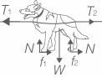
3 Tension, must be the same

Check-point 6 (p. 106)
1 B
2 B
3 50 N, U, W, W, U, 50, 45, 1, downwards, 1

Warm-up 6.4 (p. 108)
1 A
2 C

Check-point 7 (p. 111)
1 C
2
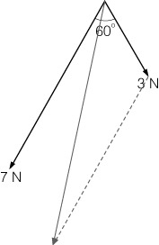
8.9 N, 43°
3 $\sqrt{{\text{120}}^{2}+{\text{120}}^{2}}$, 170

Check-point 8 (p. 116)
1 5, 1.75, 8.75, 1, 5, along, 5
2 sin 30°, 5, cos 30°, 8.66
3 A

Practice 6.4 (p. 116)
1 A
2 A
3 D
4 A

Warm-up 6.5 (p. 118)
1 (a) Yes
(b) Greater
(c) Opposite
2
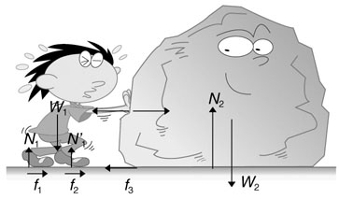

Check-point 9 (p. 121)
1 B
2 Magnitude, directions, two different bodies
3
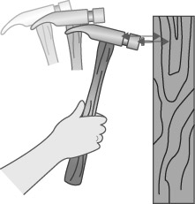

Practice 6.5 (p. 122)
1 C

Revision exercise 6 (p. 128)
1 A
2 C
3 D
4 C
5 C
6 D
7 (HKCEE 2001 Paper II Q4)
8 (HKCEE 2000 Paper II Q9)
9 D
10 (HKCEE 2002 Paper II Q6)
11 A
12 A

7 Work, Energy and Power

Warm-up 7.1 (p. 136)
1 The first case.
2 The first choice.

Check-point 1 (p. 140)
1 B
2 A
The weight component along the plane = W sin θ
⇒ work done by gravity on the block = Fs = W sin θ × d
3 20, 0.3, 37.7

Practice 7.1 (p. 141)
1 B
2 C
3 C
4 B
5 D
6 D

Warm-up 7.2 (p. 142)
1 The fist statement.
The mass and speed of the object.
2 The second statement.
The mass of the object and its vertical displacement.

Check-point 2 (p. 146)
1 0.2, 5², 2.5
0.2, 30², 90
87.5
2 50, 20
10 000
The same, weight, vertical

Practice 7.2 (p. 147)
1 A
2 A
3 C
4 B

Warm-up 7.3 (p. 149)
1 The first and third statements.
2 The first statement is always right.
The second statement is correct if the potential energy at the bottom of the chute is defined as 0.
The third statement is correct if the speeds of the boat at t = x₁ and t = x₂ are considered for different slopes of the chute.

Check-point 3 (p. 157)
1 D
2 B
3 1, 5, 50
30
20

Practice 7.3 (p. 157)
1 B
2 C
3 A
4 A

Warm-up 7.4 (p. 160)
1 The first and second statements.
2 A

Check-point 4 (p. 163)
1 C
P = $\frac{E}{t}=\frac{\text{potential energy gained by the mass}}{\text{time period}}$
= $\frac{\text{mgh}}{t}$= 10 × 10 × 0.1 = 10 W
2 B
3 3, 60
65, 60
390 000
390 000, 20, 19 500

Practice 7.4 (p. 164)
1 D
2 C
3 C
4 D
5 D

Revision exercise 7 (p. 167)
1 C
2 A
3 C
4 A
5 C
6 C
7 B
8 (HKCEE 2000 Paper II Q11)
9 D
10 (HKCEE 2002 Paper II Q8)

8 Momentum

Warm-up 8.1 (p. 176)
1 C
2 B

Check-point 1 (p. 178)
1 B
2 B
3 0.4, 20, 8 kg m s⁻¹
4 (a) v = $\sqrt{2\text{gs}}$
= $\sqrt{2×\text{10}×1\text{.}8}$ = 6 m s⁻¹
1.5 × 6, 9 kg m s⁻¹
(b) Gravitational, time

Check-point 2 (p. 186)
1 A
2 $\frac{1}{2}$× (1 + 5) × 4, 12 N s
$\frac{\text{12}}{5}$, 2.4 N
3 1000 × 8, 8000 kg m s⁻¹
70 × 8, 560 kg m s⁻¹
$\frac{\text{560}}{4}$, 140 N
4 24.5, −2.45
−2.45, 24.5
−2156
2156 N, downwards, greater

Practice 8.1 (p. 187)
1 C
2 B
3 B
4 B
5 B

Warm-up 8.2 (p. 189)
1 C
2 B

Check-point 3 (p. 194)
1 A
2 (a) 5², 4², 33
$\frac{1}{2}$ × (2 × 1² + 1 × 4²), 9 J
Some, inelastic
(b) = $\frac{1}{2}$ × (2 × 2² + 1 × 0²) = 4 J
= $\frac{1}{2}×\left[2×{\left(\frac{2}{3}\right)}^{2}+1×{\left(\frac{8}{3}\right)}^{2}\right]$ = 4 J
No kinetic energy is lost in the collision, the collision is elastic.

Check-point 4 (p. 200)
1 B
Let v be the recoil speed of the cannon.
By conservation of momentum,
momentum of the cannon = −(momentum of the ball)
1500v = −0.5 × 40
v = −0.0133 m s⁻¹
2 (a) Gravitational
(b) Earth
3 Momentum, kinetic energy, momentum, kinetic energy
4 8000, 20 × 5, 5, 20, 500
94.9 m s⁻¹

Practice 8.2 (p. 201)
1 B
2 B
3 C

Revision exercise 8 (p. 205)
1 C
2 C
3 D
4 D
5 (HKCEE 1999 Paper II Q8)
6 (HKCEE 2000 Paper II Q10)
7 (HKCEE 2001 Paper II Q111)
8 (HKCEE 2002 Paper II Q12)

